Shane Bramley Project 3: Human Benchmark 10/27/2020

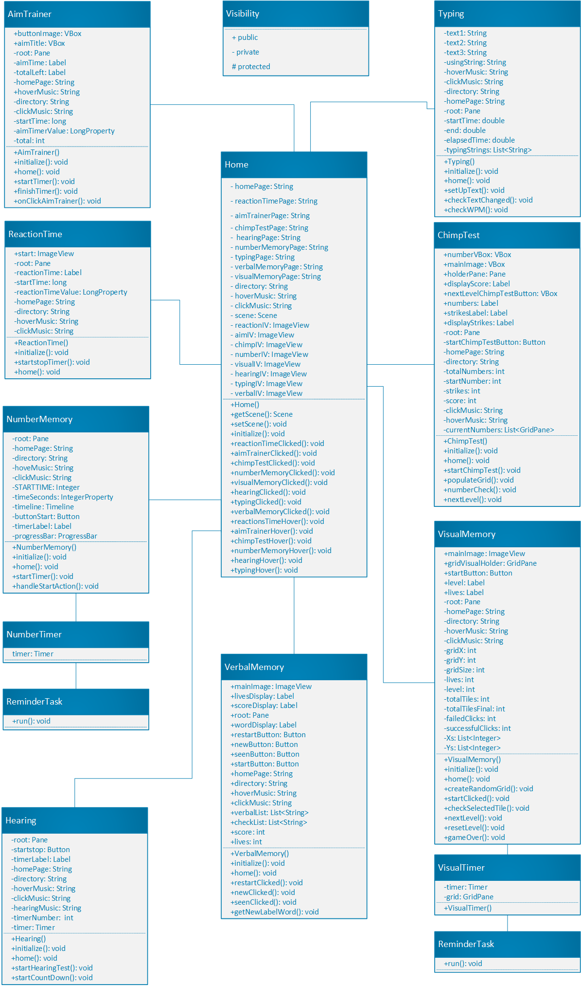

**Program 3 Human Benchmark Diagram:**

Above is the UML diagram of the Human Benchmark program this diagram consists of all of the classes need for each application mini game of the human benchmark application

**Visibility:** This was given by the instructor in lecture to show how to differentiate the signs for public private and protected Variables and methods within each class.

**AimTrainer:** This class consists of the variables and methods for the aim trainer mini game with in human benchmark this class is used to display a target and control the onclick even of the user to move the target and count down the total number of targets while also keeping track of how quick the user is clicking all 30 of the targets. Methods include:

* Constructor – initialize variables
* Initialize – Initialize variables
* Home – Go back to home page
* StartTimer – Start the aim trainer timer
* FinishTimer – Stop timer
* OnClickAimTrainer - Triggered on click of the targets

**Reaction Time:** This class was partially built by the instructor. The class controls the reaction time mini game to see how fast the user can click the box change. Method include:

* Constructor – Initialize variables
* Initialize – Initialize mini game and variables
* Home – Go back to home page
* StartTImer – Marks the start time of the click of the user
* FinishTImer – Marks and calculates the amount of timer it took the user to click
* HandleStart action – controls the on click action of the user

**Number Memory:** This class controls the logic for the number memory mini game. The class controls which number is randomly displayed to the user then starts a timer and then the number disappears and the user is asked to input the number that was just displayed. The number is then checked. If correct the user goes on to the next level if fail they lose and have to restart. Methods included:

* Constructor – Initializes the number memory variables
* Initialize – Initialize the variables on page start
* Home – Triggered by click and goes back to home
* StartTimer – Starts the timer for amount of timer to see the number
* SubmitAction – On click of submit button to submit the number that was entered in for check

**Hearing:** This class controls the hearing mini game in the human benchmark application. The logic includes starting the sound then running the amount of hertz that are being heard by the user. Methods Include:

* Constructor – This method will initialize the hearing class variable values
* Initialize – This method will initialize the values of the variables within the hearing class on page start
* StartHearingTest – This method will start the sound for the user to start hearing it will also call the timer number
* StartCountDown – This method will start the countdown of the hertz

**Verbal Memory:** This class will control the verbal memory mini game. It includes the methods to show the given words and the user can decided if they have seen the word before or it is new. Methods include:

* Constructor – Initialize variables
* Initialize – Initialize mini game and variables
* Home – Go back to home page
* Restartclicked – restarts the game
* Newclicked – word is a new word
* Seenclicked – word has been seen already
* getNewLabel – gets the new word and adds it to the visual for the user to see

**Typing:** This class is used to control the logic for the typing mini game within the human benchmark application. It controls things like which paragraph will be displayed, and if the letter that was typed is corrected to the word shown

* Constructor – Initialize variables
* Initialize – Initialize mini game and variables
* Home – Go back to home page
* SetupText – This method will set up the paragraph that will be displayed
* Checktextchange – This method is triggered on text change
* CheckWPM – This method will check the words per minute that the user has typed

**Chimp Test:** This class is used to control the logic of the chimp test mini game in the human benchmark application. The chimp test is a test to see how man numbers the user can remember where there locations are when they are covered. Methods Include:

* Constructor – Initialize variables
* Initialize – Initialize mini game and variables
* Home – Go back to home page
* StartChimpTest – this method will start the chimp test by displaying the numbers
* populateGrid – This method will populate the grid of the numbers for the user to see
* numberCheck – This method will check the number that the user clicked on the grid
* NextLevel – This method will repopulate the grid of number and set up the next level

**Visual Memory:** This class will control the logic for the visual memory mini game within the human benchmark application. The class consists of methods to control the boxes being displayed then make the boxes disappear.

* Constructor – Initialize variables
* Initialize – Initialize mini game and variables
* Home – Go back to home page
* createRandomGrid – This method will build the grid with the color boxes
* startClick – This method is triggered by the start button click and will call the create random grid method
* checkSelectedTile – This method will check the selected grid whenever the tile is clicked
* nextLevel – This method is triggered by the next button clicked and will reset and repopulate the grid
* resetLevel – This method will reset the level if the user still has lives left
* gameOver – This method will be called if there are no lives left to keep the visual memory mini game running

**Home:** This method will run the Human Benchmark game. It is the logic controller for the main menu of the application. It will control the selection of all of the various mini game with in the Human Benchmark application Methods include:

* ReactionClicked, Hover, Exit – This started the Reaction test
* AimClicked, Hover, Exit – This starts the Aim test
* HearingClicked, Hover, Exit – This starts the Hearing Test
* VerbalMemoryClicked, Hover, Exit – This starts the Verbal memory test
* VisualMemoryClicked, Hover, Exit – This starts the Visual Memory test
* ChimpTestClicked, Hover, Exit – This starts the chimp test
* NumberMemoryClicked, Hover, Exit – This changes the number memory test
* TypingClicked, Hover, Exit – This starts the typing test